Custom Handy Hat™ Form

Contact Information
Name: __________________________________ Phone: ______________________
Email: ________________________________________

Color (please circle)

Light Blue Pink Navy White Black Pink

Yellow Purple Tan Orange Red Brown Gray

Design:
Front | Back
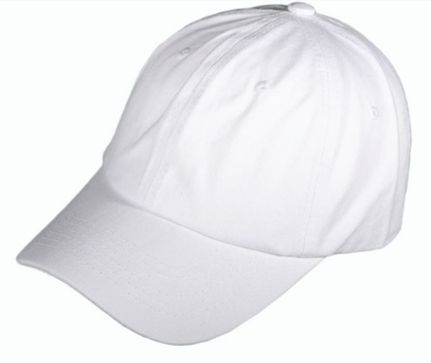 | 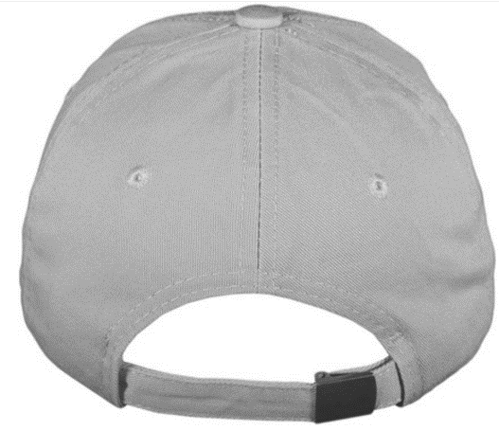
Details: | Details:

Quantity: ______
*minimum quantity of 24 hats!
*email completed form to dani@myhandyhats.com

